**“Bulk SMS and Email Delivery System”**

**A Major Project Synopsis Submitted to**



**Rajiv Gandhi Proudyogiki Vishwavidyalaya, Bhopal**

**Towards Partial Fulfillment for the Award of**

**Bachelor of Technology**

**(Computer Science and Engineering)**

**Submitted By**

**Aryan Dame (0827CS191054)**

**Anurag Chauhan (0827CS191048)**

**Anirudha Khode (0827CS191040)**

**Aditya Trivedi (0827CS191015)**

**Under the Supervision of**

**Prof. Shivshankar Rajput**

**Assistant Professor**

**CSE, AITR, Indore**



**Department of Computer Science and Engineering**

**Acropolis Institute of Technology & Research, Indore**

**Jan-Jun 2023**

# Abstract

# Bulk emailing and messaging refer to the distribution of a large number of emails and messages for delivery to mobile phones and computer systems. It is utilized by media companies, enterprises, banks for marketing and fraud control, and consumer brands for a variety of purposes, including entertainment, business, and mobile marketing. SMS (Short Message Service) and email (electronic mail), as text messaging services, offer the convenience of instant communication by allowing the sending of emails and text messages to anyone, anytime and anywhere. The bulk email and SMS system enhance this capability by enabling the efficient sending of multiple emails and messages to the desired recipients with reliability.

# Introduction of the Project

# A bulk SMS or email service that can effectively communicate information to a large audience in a brief period is necessary. It may encompass important alerts, warnings, and news that must be delivered to all citizens of a country simultaneously. This app will permit the sending of bulk emails and SMS to users in a single transmission using SMTP or other technology, also ensuring that all users receive a notification on their mobile devices.

# Objective

# We require a mobile/web app that will enable the sending of bulk emails and SMS to users in a single transmission using SMTP or other technology, ensuring that all users receive a notification on their mobile devices.

# Additionally, features such as log generation, notification of failed SMS and/or email delivery, scheduling of SMS/emails, a scheduler alert/notification system, creation of users with different roles and responsibilities, read/unread status, the ability to import contact details from Excel worksheets, and customization of emails with the recipient's name should also be included.

Above mentioned were the specific project objectives. Here are some common objectives of designing a bulk email and SMS service-providing app:

1. **Deliverability**: To ensure that the emails and SMS are delivered to the recipient's inbox and mobile, respectively.
2. **Ease of use:** To provide a user-friendly interface for users to send bulk emails and SMS with minimal effort.
3. **Personalization**: To allow for personalization of emails and SMS with the recipient's name, etc.
4. **Analytics**: To provide advanced reporting and analytics features to track the effectiveness of bulk email and SMS campaigns.
5. **Integration**: To integrate with other tools such as CRM systems to manage contacts and target specific audiences.
6. **Automation**: To provide automation capabilities for targeted and automated email and SMS campaigns.
7. **Cost-effectiveness:** To offer an affordable solution for sending bulk emails and SMS.
8. **Security**: To ensure that the app is secure and data is protected from unauthorized access.

# Scope

The scope of a bulk email and SMS delivery app encompasses the ability to send large volumes of emails and SMS to multiple recipients in a single transmission. The app should provide a user-friendly interface for sending messages, allow for personalization and customization of emails and SMS, and provide advanced reporting and analytics features. The app should also be integrated with other tools such as CRM systems and offer automation capabilities for targeted and automated email and SMS campaigns. The app should be cost-effective, secure, and designed to ensure high deliverability rates for both emails and SMS. The scope of the app should meet the specific needs and requirements of the users, making it an essential tool for businesses and organizations looking to effectively communicate with their audience.

# Study of Existing System

We have studied some applications and systems that are already available for sending bulk SMSs and Emails and their limitations. Some of the currently existing systems and their shortcomings are described below:

* **Plivo**

Plivo’s cloud communication platform offers a simple, fast, and scalable way for companies to modernize their business communications. Plivo’s API platform lets businesses quickly incorporate voice and text messaging capabilities (both SMS and MMS) into their applications, and it offers SIP truncating and phone number rental services.

* **Advantages**:
* Ease Of Integration
* API Call Speed
* Communication Varieties
* Documentation Available
* **Disadvantages**: It is expensive and majorly meant for business purposes.
* **Gaps Identified**: It cannot be used in small organizations with low budgets.
* **Reference** **link**: [https://www.plivo.com](https://www.plivo.com/)
* **Atomic SMS Sender**

This is an online application that allows users to send bulk SMS from their phones or computers. The application can be used to send SMS to over 200 countries and supports over 700 mobile operators.

* **Advantages**:
* Easy contact management
* Can schedule messages at anytime
* Live online training and documentation are readily available
* Offers unsubscribe feature for the audience to make them feel privileged.
* **Disadvantages:**
* 2-way messaging is not possible
* MMS and mobile coupons are also not possible
* Sometimes SMS doesn’t get delivered on time.
* **Gaps Identified:** Lack the ability to personalize emails, making them appear generic and lacking in engagement.
* **Reference Link**: <https://sourceforge.net/software/product/Atomic-SMS-Sender/>
* **My SMS Mantra**

My SMS Mantra is a free software for sending bulk SMS that enables the user to send SMS online, using an Excel plug-in. All you need is to download and install the Excel plug-in and then stay connected to your clients/customers via SMS

* **Advantages**:
* Seamlessly interfaces with other applications through its API
* Easy to set up with no hidden costs
* Has free technical support
* Allows 2-way messaging thanks to its Mantra Communication
* **Disadvantages**:
* The word limit for SMS messages is too short
* Might lose data put in the software if you face network issues
* **Gaps Identified**: The pricing depends on the kind of SMS to be sent – whether it is a transactional or a promotional SMS.
* **Reference Link**: [https://www.mysmsmantra.com](https://www.mysmsmantra.com/)

# Project Description

The bulk email and SMS service project aims to enhance the way of communication between businesses and their audience. The app will allow businesses to send large volumes of emails and SMS to multiple recipients in a single transmission, saving time and effort. The app will have a user-friendly interface for sending messages and offer advanced reporting and analytics features to track the success of each campaign. The app will also offer personalization and customization options for emails and SMS, allowing businesses to tailor their messages to their audience. The app will be integrated with other tools such as CRM systems, allowing businesses to automate targeted email and SMS campaigns and reach their audience more efficiently. The app will be designed to ensure high deliverability rates for both emails and SMS, ensuring that messages reach the intended recipients. The bulk email and SMS service project will provide businesses with a cost-effective and secure way to communicate with their audience, enhancing the way of communication and helping businesses reach their goals.

# Methodology/Planning of the Project work

The complete planning of designing and developing the proposed application is given below:

First, we will create a splash screen for the application followed by a login page. The login page will also have the option for registration. Next, we have to code the registration page for the new users. It will ask for all the necessary information for basic registration. After logging in, the user can choose from two options: SMS or Email.

* **SMS:** The SMS screen will have the Browse option to attach the contact number of all receivers. Next, it will be the message box followed up by a Send button.
* **Email:** The email screen will have the Browse option to attach the email contacts of all the receivers. Next, it will be the Subject box and Message box followed by the Send button.

Next, the implementation of the main code will be done followed by a confirmation screen showing if the message was sent or not.

**Flowcharts**

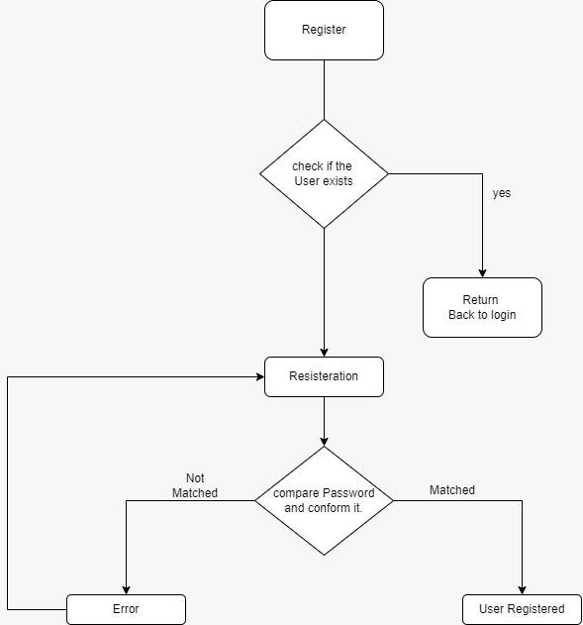

**Fig 1.1** Registration Flow Chart

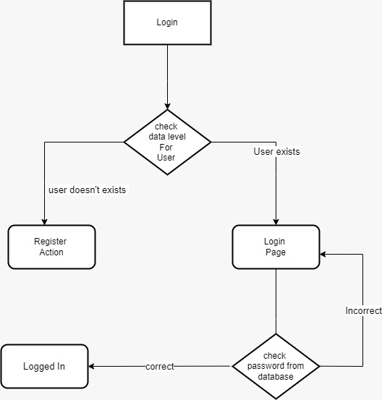

**Fig 1.2** Login Flow Chart

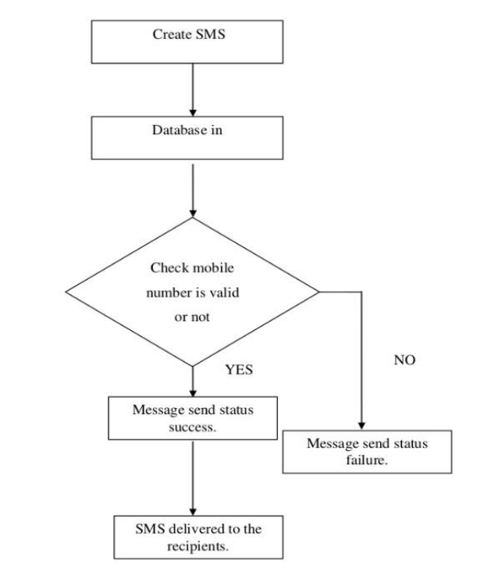

**Fig 1.3** Message Flow Chart

# Expected Outcome

While SMS (Short Message Service), a text messaging service, elicits the appeal of instantaneous communication by using mobile technology to send a text message to anyone anytime and anywhere.

The bulk SMS system has expanded the capability of SMS by implementing the ability to easily send multiple SMS messages to intended recipients with reliability.

The advantages of bulk SMS can be applied in schools and universities to further develop classroom interactions and set up a virtual community as a public relations system. Lecturers can conduct mobile quizzes in many question forms with their students via SMS.

# Resources and Limitations

**Resources**

Below mentioned are the resources that will be required for designing the proposed application:

# Hardware Requirements:

# Processor: Intel core i3

# RAM: 2GBs

# Hard Disk: 80 GBs (Memory Consumption: 5 MB while in use)

# Software Requirements:

# Operating System: Windows 7

# Frontend: Python Tkinter

# Backend: MySQL

**Limitations**

Below mentioned are some of the limitations of the system proposed:

1. **SMS Character Limit:** One of the limitations of bulk SMS service is the character limit for each message. SMS services usually have a limit of 160 characters for each message, which can be a constraint for conveying detailed information.
2. **Delayed Messages:** Another limitation of bulk SMS and email services is the possibility of delayed messages. Factors such as network congestion, server downtime, or technical issues can result in delayed delivery of messages.
3. **Server Problems:** The app's performance and reliability are dependent on the server infrastructure. Server downtime, slow performance, or technical issues can affect the app's ability to send bulk SMS and emails and can result in missed or delayed messages.

These are some of the limitations of bulk SMS and email service-providing apps. Despite these limitations, these apps can be effective communication tools when used in conjunction with other marketing and communication strategies. The key is to choose a reliable app with robust features and a proven track record of delivering messages promptly and effectively.

# Conclusion

This project is widely used in organizations, colleges, banking, companies, E-Commerce, Market News, Government & Public Utilities, Logistics, Media & Entertainment, Travel & Tourism Industry, etc. Alert your customer/user about the new updates of organizations/colleges. In Logistics, it is used to send shipping updates, invoices, bills, tracking detail web URLs, and much more via SMS. In Media & Entertainment, it is used to invite the audience to an FM/TV show or ask the audience to vote for their favorite contestants in your reality show. and it is also used in Travel & Tourism Industry to become a travel buddy of your customer by sending all the itineraries and travel routes via an SMS to make their journey more hassle-free.

In all, this project has multiple use cases and therefore it proves to be one of the significant solutions to real-world communication problems.

# Bibliography

1. [Textlocal: India's #1 Bulk SMS Service | Send & Receive Bulk SMS Online](https://www.textlocal.in/)
2. [Bulk Email. Delivered. | Sendinblue](https://landing.sendinblue.com/bulk-email/)
3. <https://www.ncbi.nlm.nih.gov/pmc/articles/PMC4730887/>
4. <https://www.researchgate.net/publication/314515357_Design_and_Implementationof_a_Bulk_SMS_and_Email_Marketing_System>
5. <https://www.sciencedirect.com/science/article/abs/pii/S0263237314002348>
6. <https://ieeexplore.org/abstract/document/4767378>
7. <https://link.springer.com/article/10.1057/bm.2012.13>
8. <https://ieeexplore.org/abstract/document/8696527>